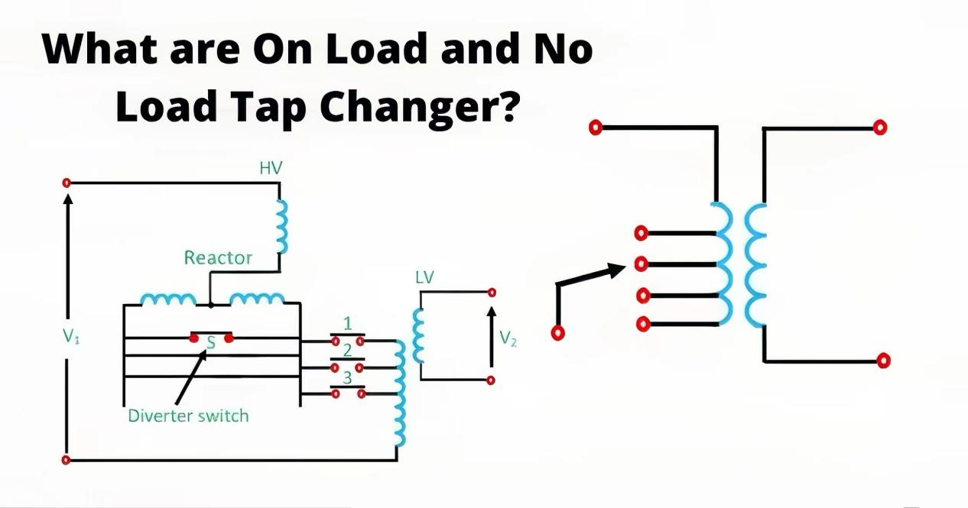
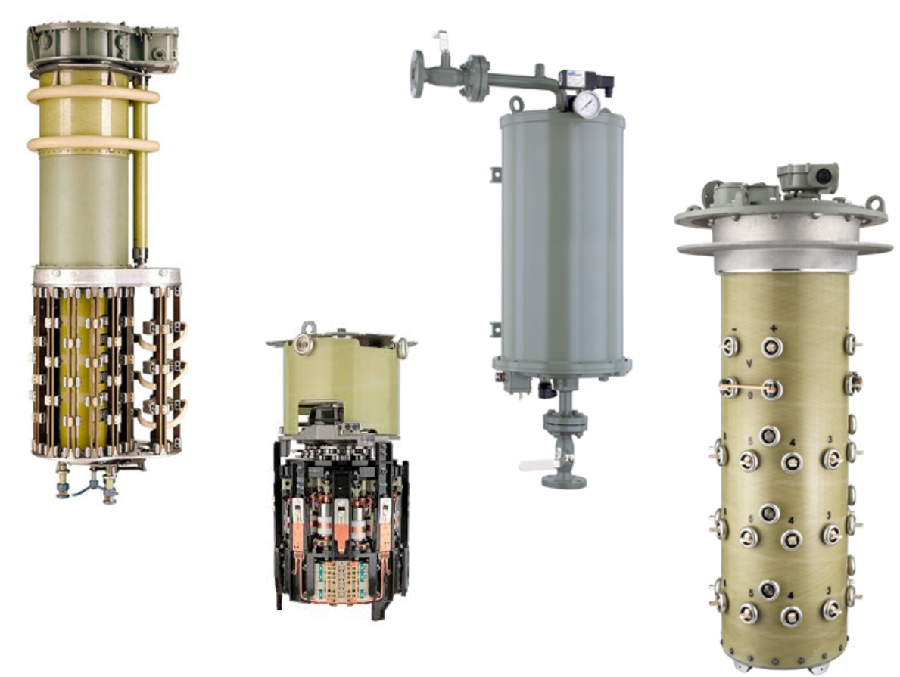
NLTC vs. OLTC: The Great Transformer Tap Changer Showdown! ⚡️
Hey there, transformer enthusiasts! Ever wondered what makes your power transformer tick? Well, today, we’re diving into the fascinating world of tap changers—those unsung heroes that keep your voltage just right. But what’s the difference between NLTC and OLTC? Let’s break it down with a bit of flair!

Meet NLTC: The No-Drama Tap Changer
First up, we have the NLTC (No-Load Tap Changer)—the chill, low-maintenance cousin of the tap changer family. This guy only steps into action when the transformer is off-duty. Yup, you heard that right! The NLTC is like that friend who only helps you move house when everything’s already packed and the heavy lifting is done. It’s simple, cost-effective, and perfect for situations where voltage doesn’t need constant tweaking.

Why Choose NLTC?
- Reliability: NLTCs are robust and less complex, making them easier to maintain. They’re the strong, silent type—no fuss, just results.
- Economical: With fewer moving parts and less frequent usage, NLTCs offer a budget-friendly solution for systems where power demand is stable.
- Easy to Use: No need for high-tech monitoring or continuous adjustments—NLTCs are set-and-forget.

Popular Brands:
- ABB: Known for their reliability, ABB’s NLTCs are built like tanks—simple and sturdy, ideal for long-term operations.
- Siemens: Bringing a bit of German engineering to the table, Siemens offers NLTCs that are precise, long-lasting, and require minimal maintenance.

Enter OLTC: The On-Demand Hero
Now, let’s talk about the OLTC (On-Load Tap Changer)—the superhero of tap changers. Unlike NLTC, OLTC is ready to make adjustments while the transformer is live and under load. It’s like having a superhero who adjusts the voltage without ever taking a break. Whether the grid’s under pressure or the load is changing, OLTC keeps everything running smoothly—no interruptions, no sweat.

Why Choose OLTC?
- Dynamic Performance: OLTCs are the go-to for systems where loads fluctuate frequently. They adapt in real-time, ensuring your system stays balanced and efficient.
- Continuous Operation: With OLTC, there’s no need to power down for adjustments. It’s all about keeping the show on the road, even when the road gets bumpy.
- Advanced Control: OLTCs come with sophisticated controls, allowing precise voltage regulation and optimization for complex power systems.

Popular Brands:
- MR (Maschinenfabrik Reinhausen): These OLTCs are the Ferraris of the tap changer world—fast, reliable, and built for high performance. They’re the choice when you need top-tier operation without compromise.
- Eaton: If you’re looking for versatility, Eaton’s OLTCs have got you covered. They offer smooth operations even under heavy loads, with a reputation for durability and efficiency.

So, Which One’s for You? 🤔
It all boils down to your needs. If your transformer can afford to chill out occasionally (and you’re budget-conscious), NLTC might be your best bet. They’re reliable, economical, and perfect for systems where stability is the name of the game.
But if you’re in the fast lane, dealing with varying loads and can’t afford downtime, OLTC is your go-to. They’re the dynamic powerhouse you need to keep everything running without a hitch, even under the most demanding conditions.

Final Thoughts
At JZP, we’ve got both NLTC and OLTC options ready to meet your project’s unique needs. Whether you need a laid-back or a high-octane solution, we’re here to help keep your power flowing smoothly! Looking to upgrade or need advice on which tap changer is right for you? Drop us a line—we’re always here to chat about transformers (and maybe even a few superhero analogies too)!
